**Cryptography For Ethical Hackers**

**Learn about cryptography, one of the most important tools in modern cybersecurity, and how it’s related to Ethical Hacking.**

**What Is Cryptography**

Since before even the Roman Empire, humans needed to preserve the confidentiality of information, and one way we do that is by using cryptography. Broadly speaking, **cryptography** is the process of encrypting and decrypting data using algorithms known as ciphers. Ciphers vary broadly in their complexity, ranging from simple substitution ciphers that can be solved for fun by children to complex mathematical functions designed to resist the most powerful supercomputers we have.

The ciphers we use in modern cybersecurity are much closer to the latter than the former, but it’s often much easier to explain concepts using simple algorithms.

## Key Concepts

### Symmetric Vs. Asymmetric Encryption

**Symmetric encryption** uses the same key to encrypt and decrypt data. Symmetric encryption is faster than asymmetric encryption, but if someone is able to obtain the key from symmetric encryption, they can read and secretly modify any data they intercept.

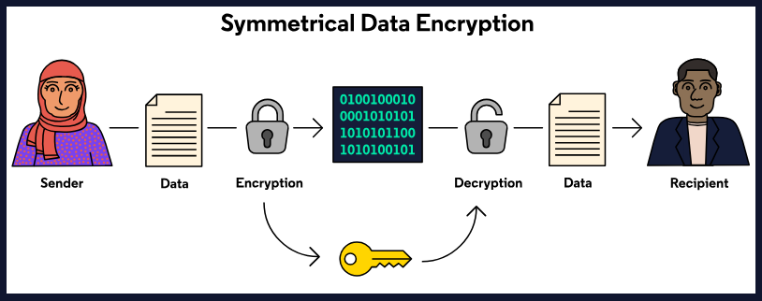

**Asymmetric** encryption uses separate keys to encrypt and decrypt data. Asymmetric encryption is slower than symmetric encryption, but it’s harder for an attacker to read or modify intercepted communications. Asymmetric encryption can also be used to verify identity as well as verify the authenticity of documents.

